University: International Burch University

Faculty: Faculty of Engineering and Natural Sciences

Department: IT

Course: CEN 101- Computer Engineering Orientation

Group members: Berina Crnčalo, Amar Đurović, Rijad Dedović and Faris Isaković

Project name: DeafHelp

PROJECT PROTOTYPE

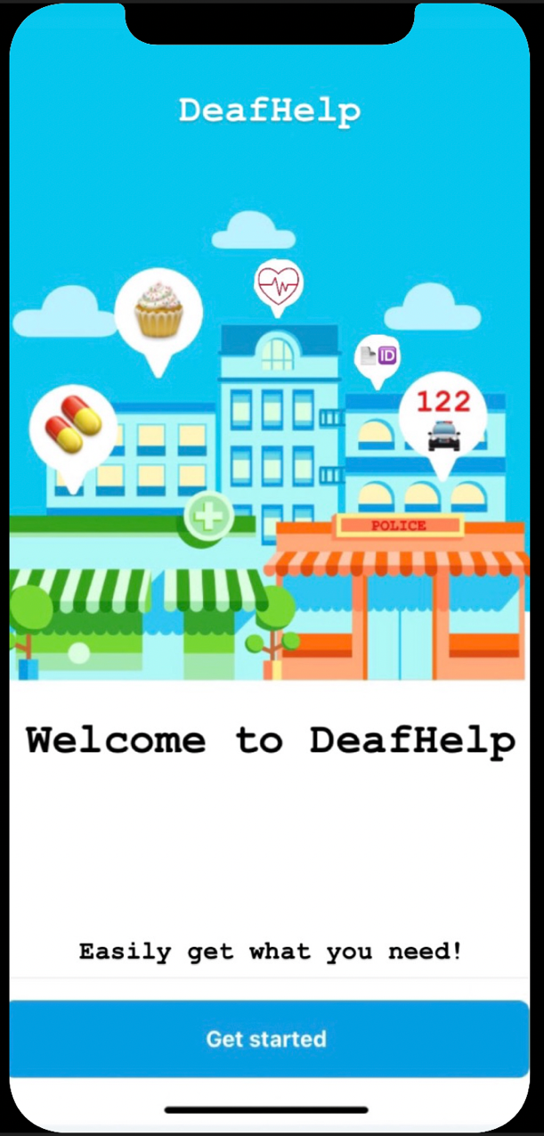

When you first open the app, you will be shown with the welcome screen, next you have to click get started.

When you click get started you will be shown a window for sign up (registration) or sign in if you already have an account.

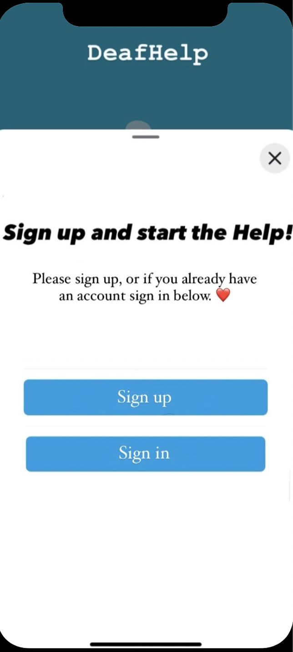

By clicking sign up you will be shown a window “Profile details”, in which you have to input information about yourself.

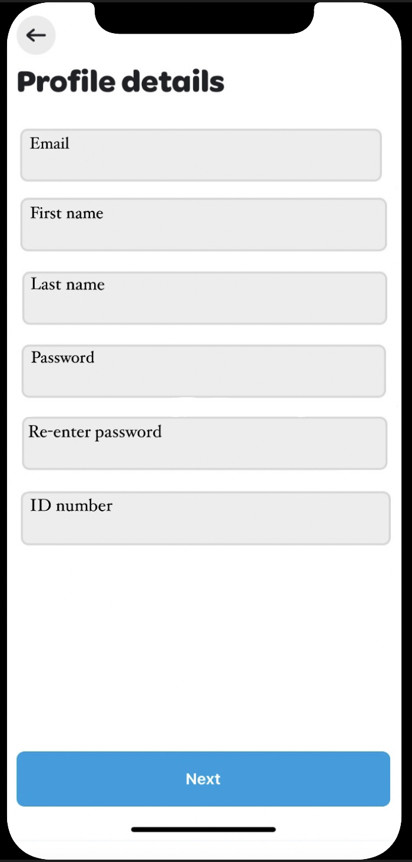

Email- Input your email address.

First name- Input your first name.

Last name- Input your last name.

Password- Write a password with which you’ll access the app in your first log in.

Re-enter password- Re-enter your password so you’ll know if you made a mistake while typing.

ID number- Input ID number, which you can find on your ID card.

Next- Takes you to the next window.

Here you will have to enter your phone number, so we can contact you via text if we need to.

Send text with code- When you click this button you will get a text message with a code, so we know that you inputted the right number. Next, input the number you got in the text continue to the next window.

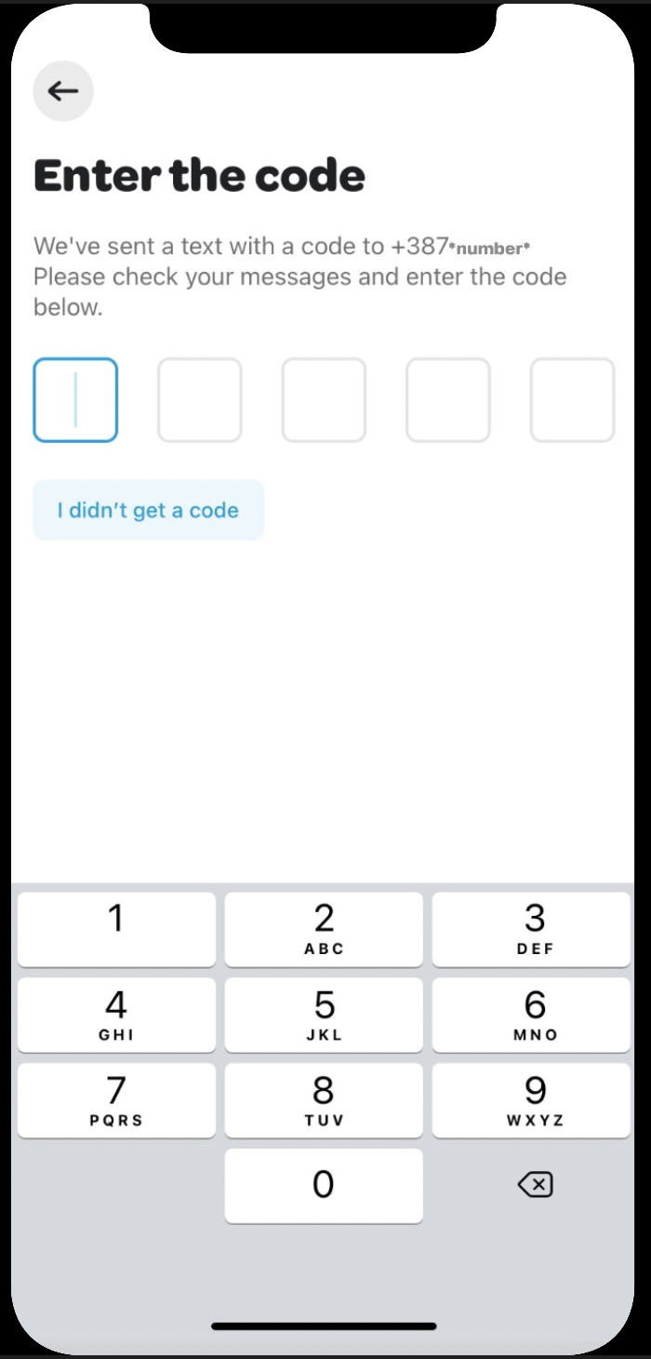

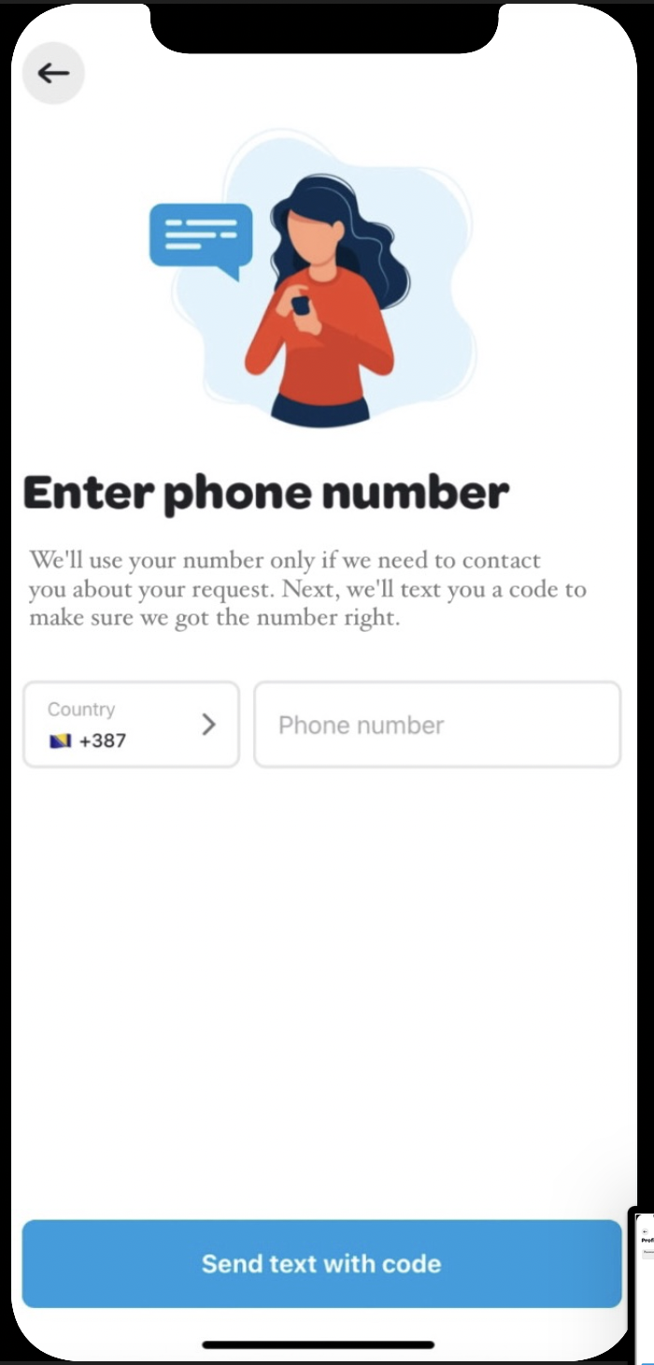

After inputting your number, you’ll be asked for your location, so we know where to deliver things to, where to come to help you in need or to tell you where the nearest facility from which you need something is.

Share your location- The location will be shared automatically.

Enter your address- You will be asked for the city, postal code, street address and number and the building number.

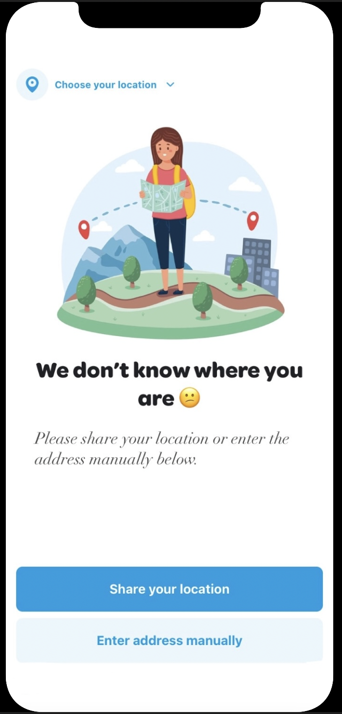

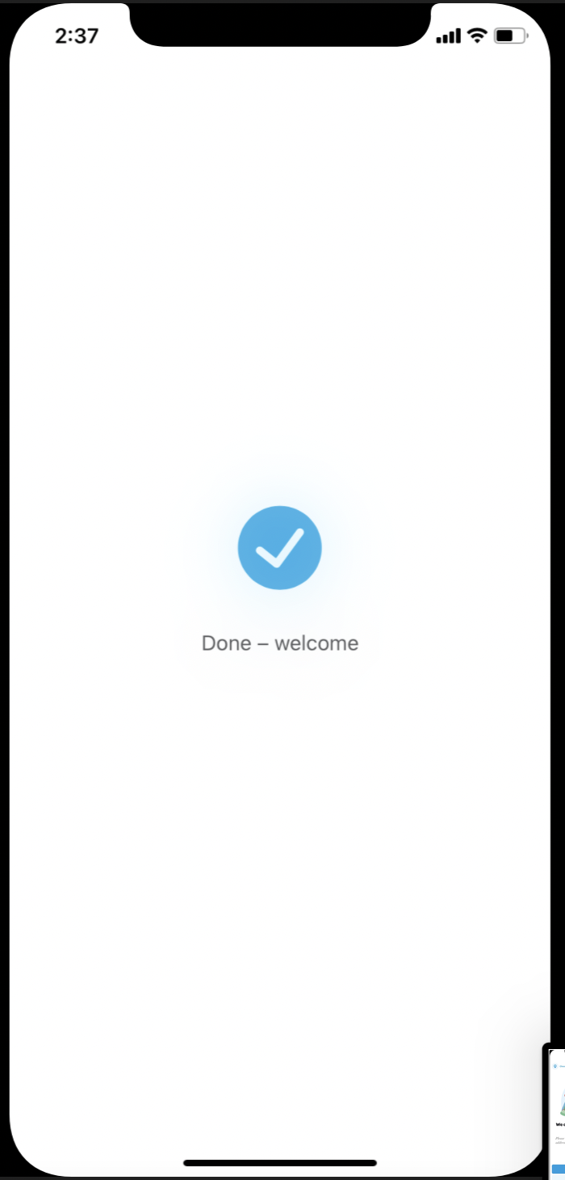By finishing this you are officially done with registration, and you’ll be shown a window “done-welcome”.

In another case, that is if you already have an account, you will be asked to log in, so:

Email- Input the email you used to register to the app

Next- Proceed to the next page

Password- Input the password used in registration

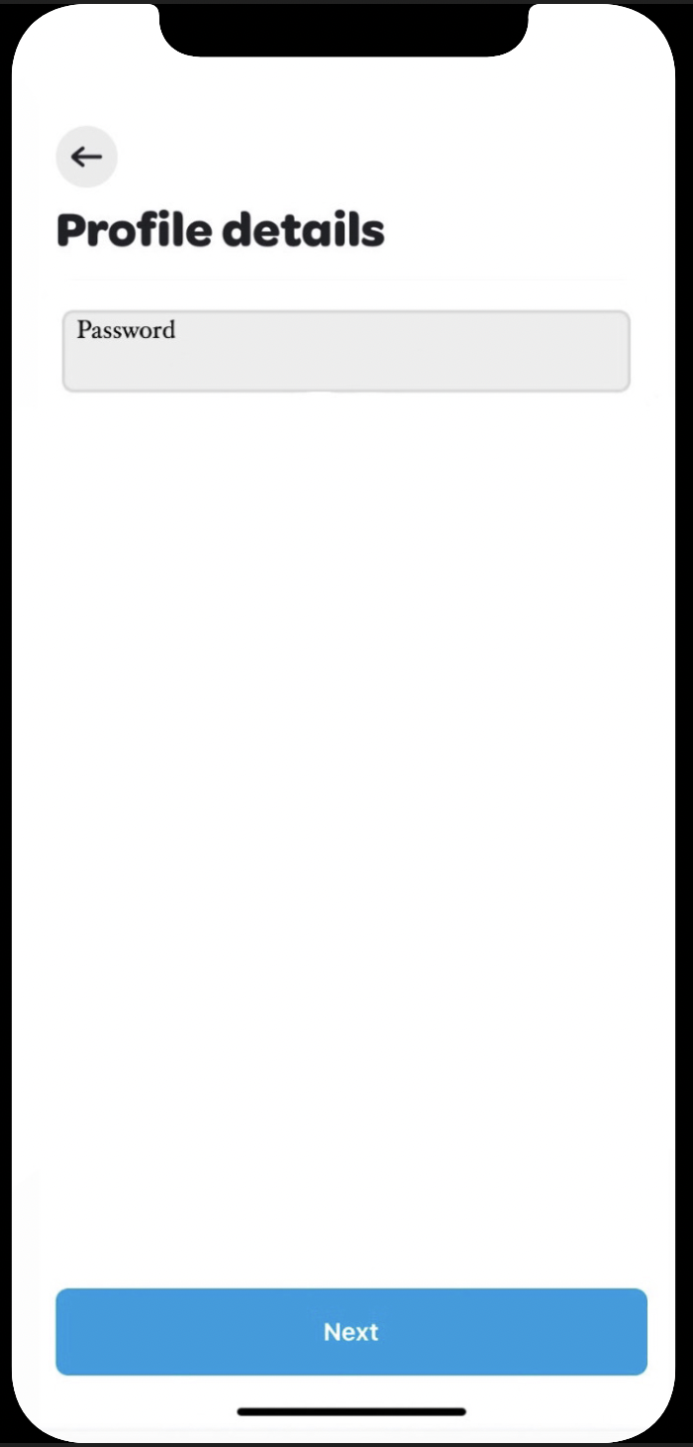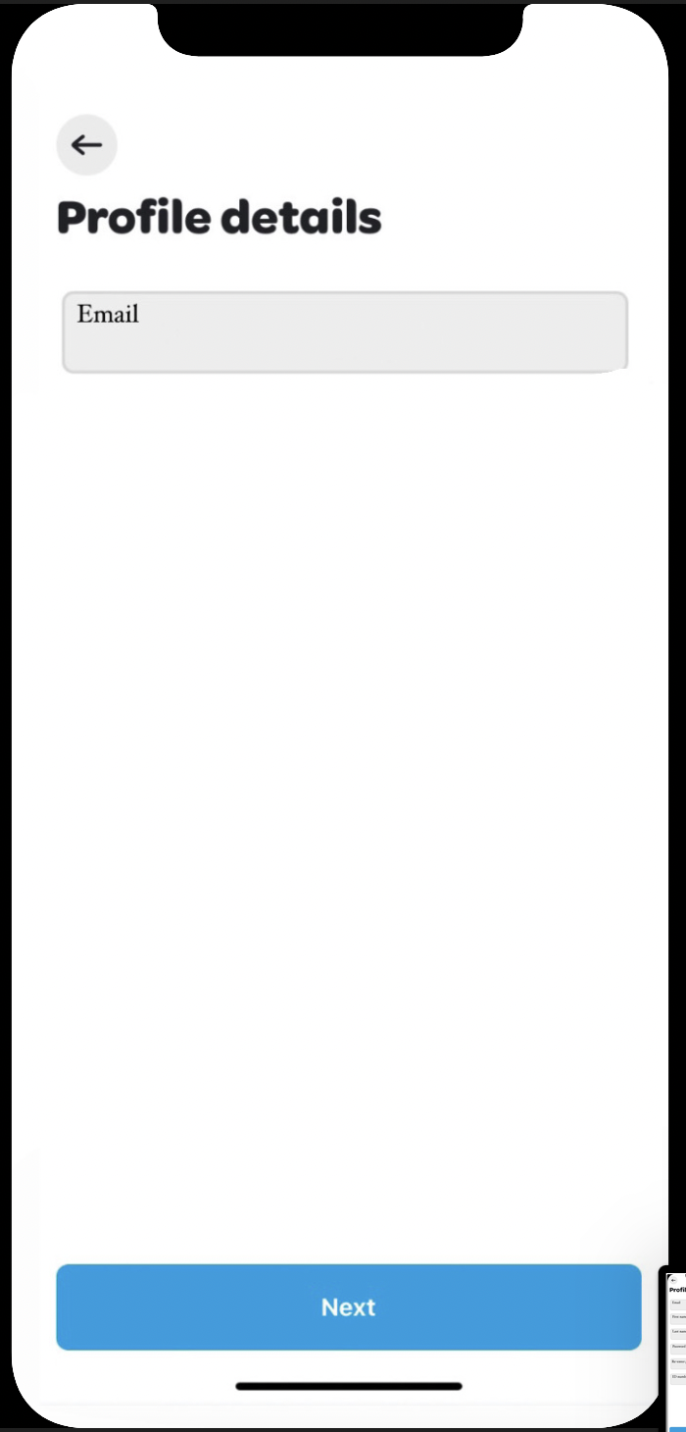Next- Proceed to the start page

Welcome to the home page of your app: we listed the main facilities we thought were important for a costumer. In the nest pages you will see some basic things that are usually asked from these facilities, if there isn’t an option that you need you can go back and ask a specific facility to help you with what you need via text message or a video call, where a person will speak to you using sign language.

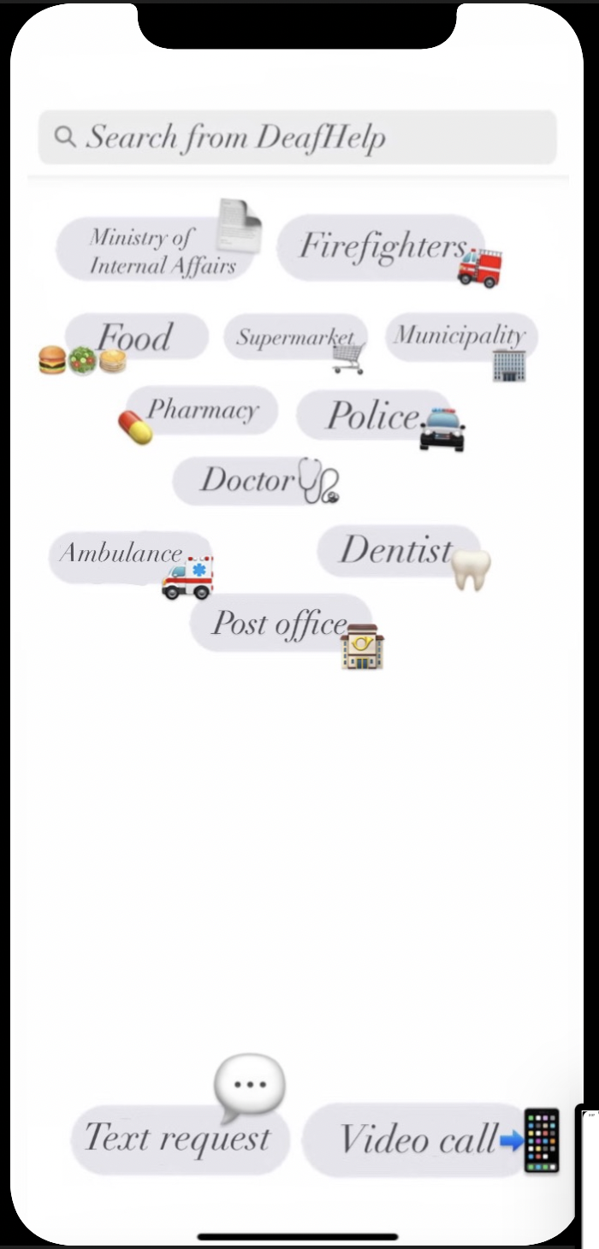

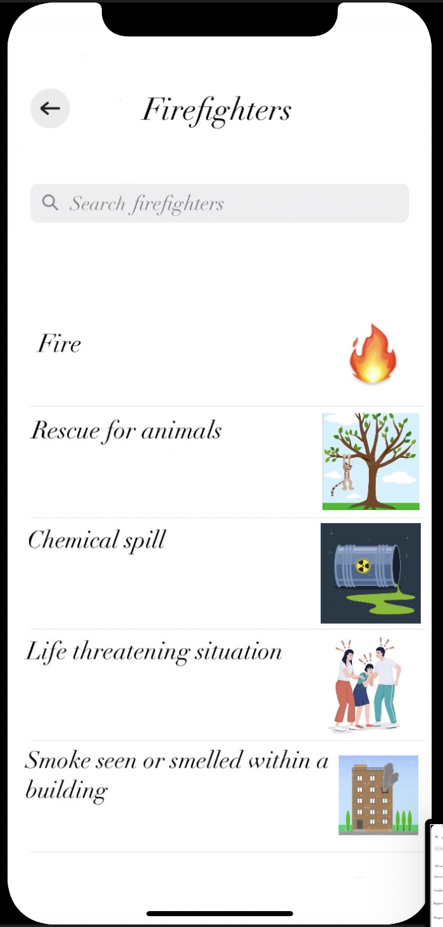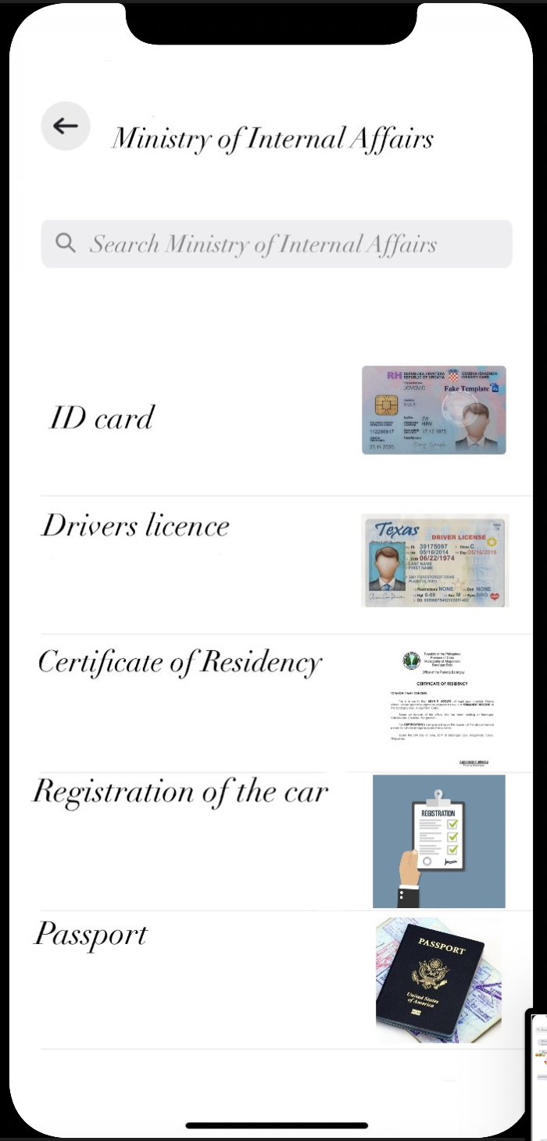When you click any of these facilities, you will be shown the following requests that are most required from users. Examples of requests from facilities:

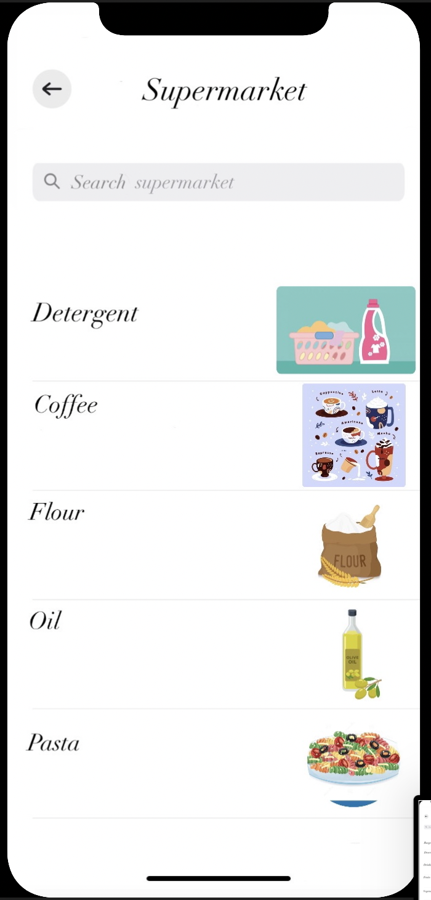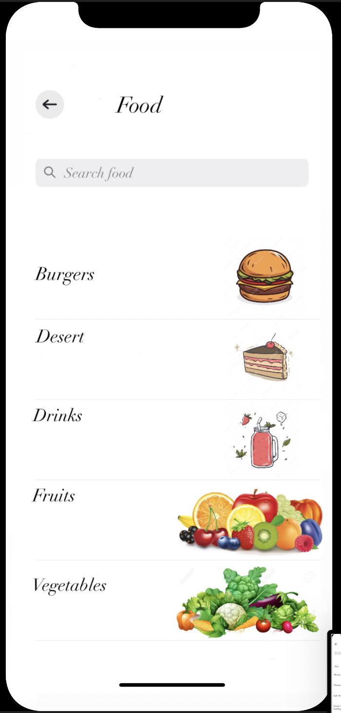

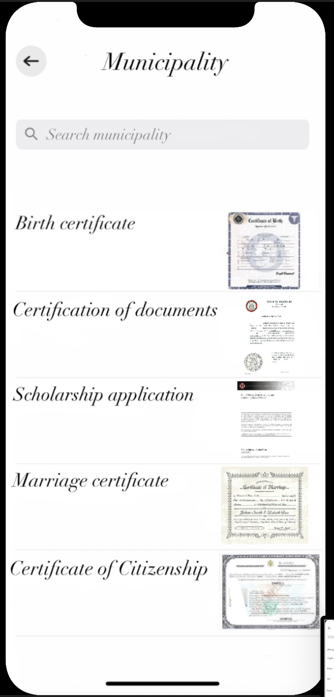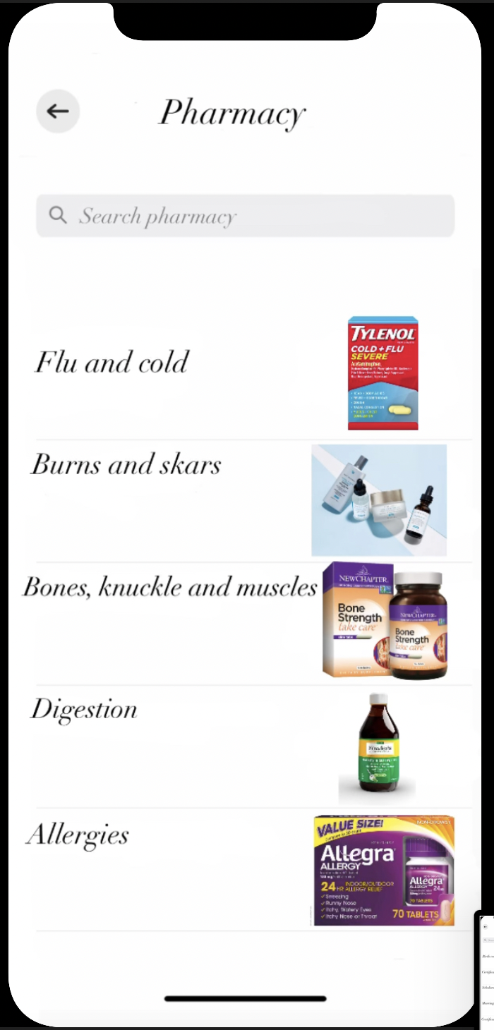

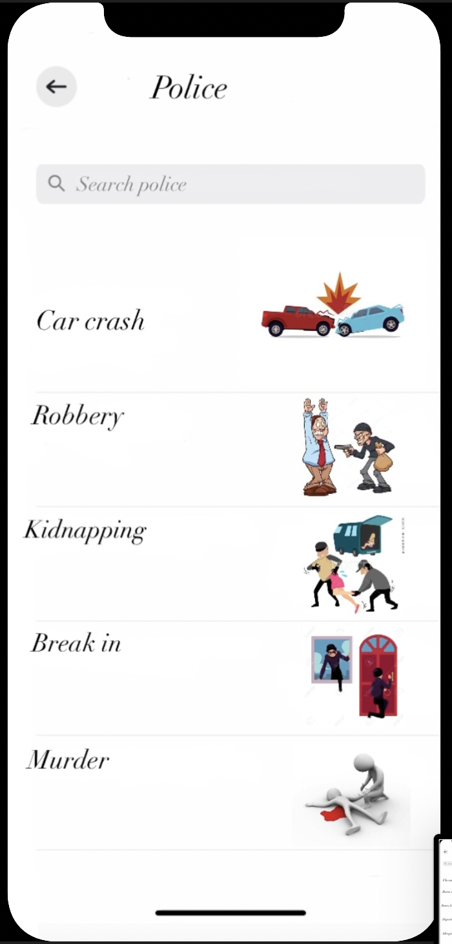

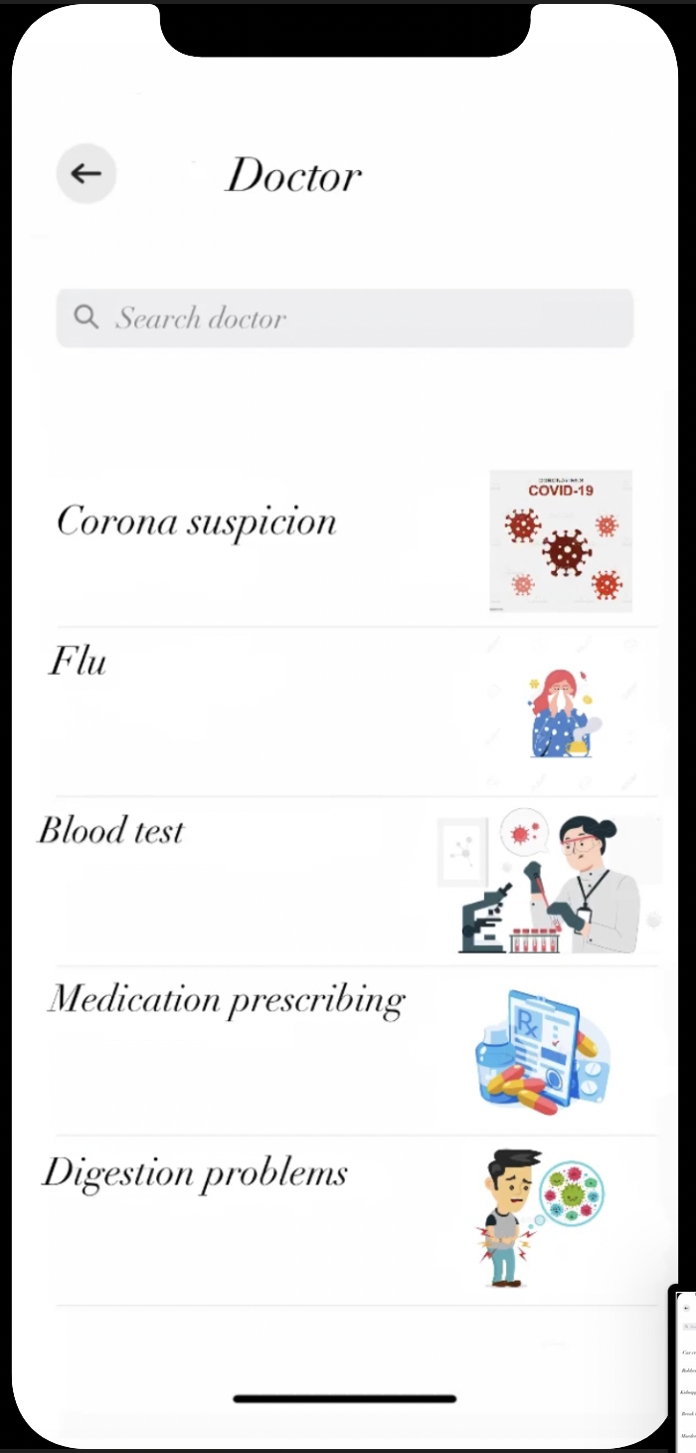

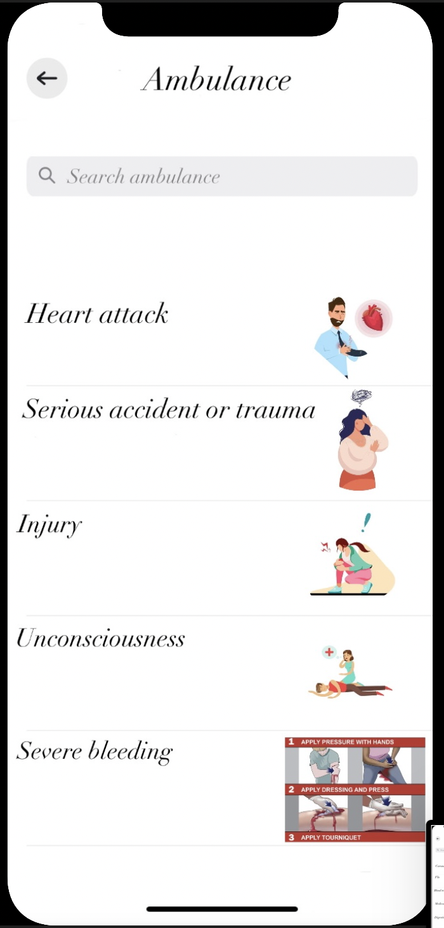

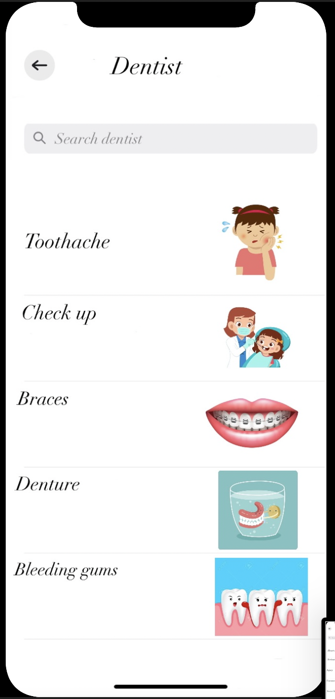

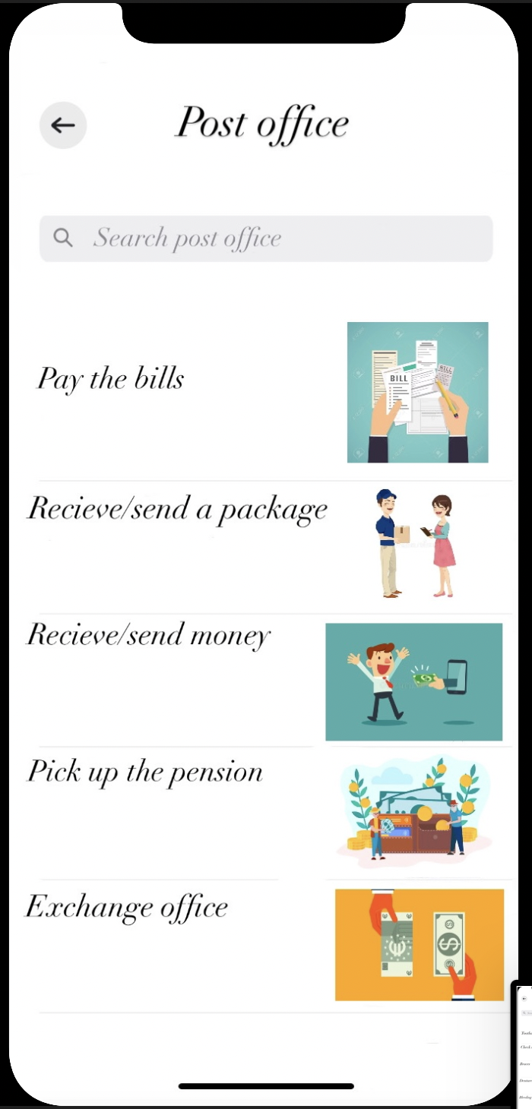

As we previously said in case there is no request suggested in the pages above, you can go back and write a text requesting what you need.

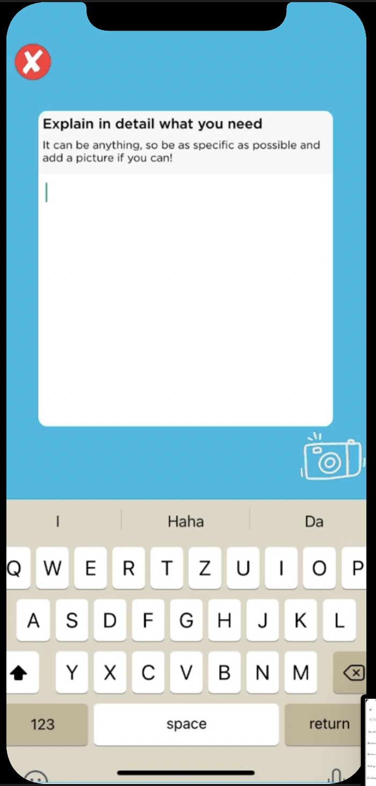

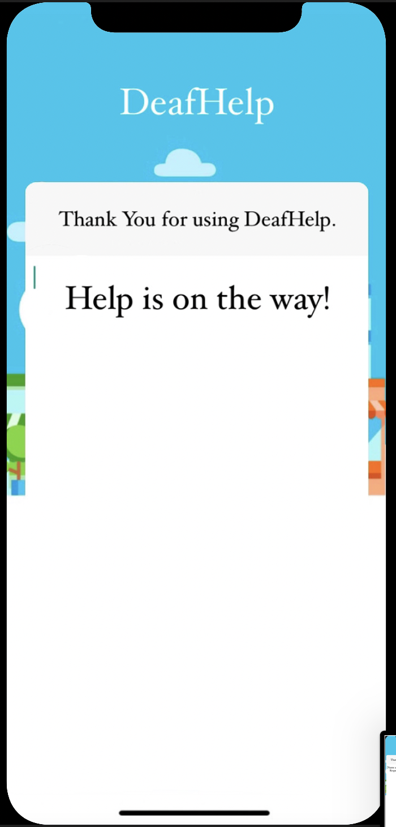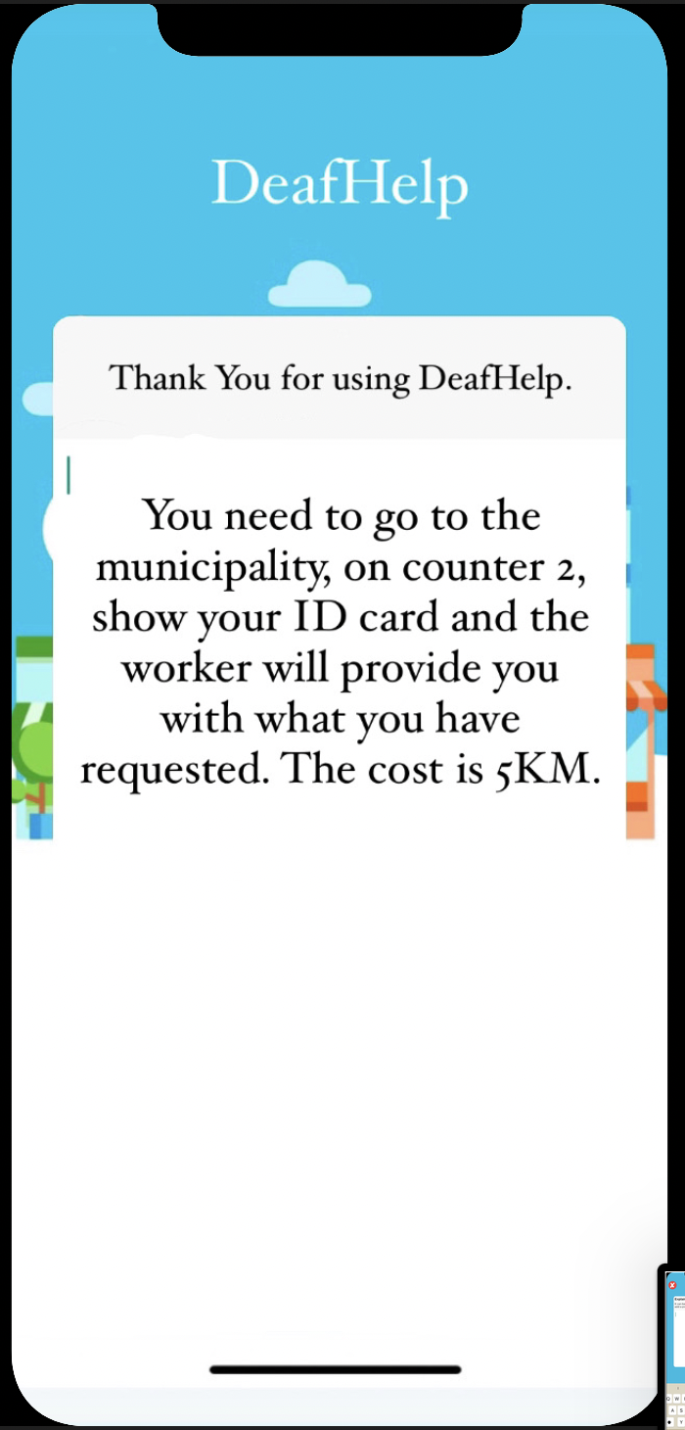After the text has been received by the DeafHelp workers, you will get feedback telling you what you should do, that the requested item will be sent to your address or that help is on the way to you.

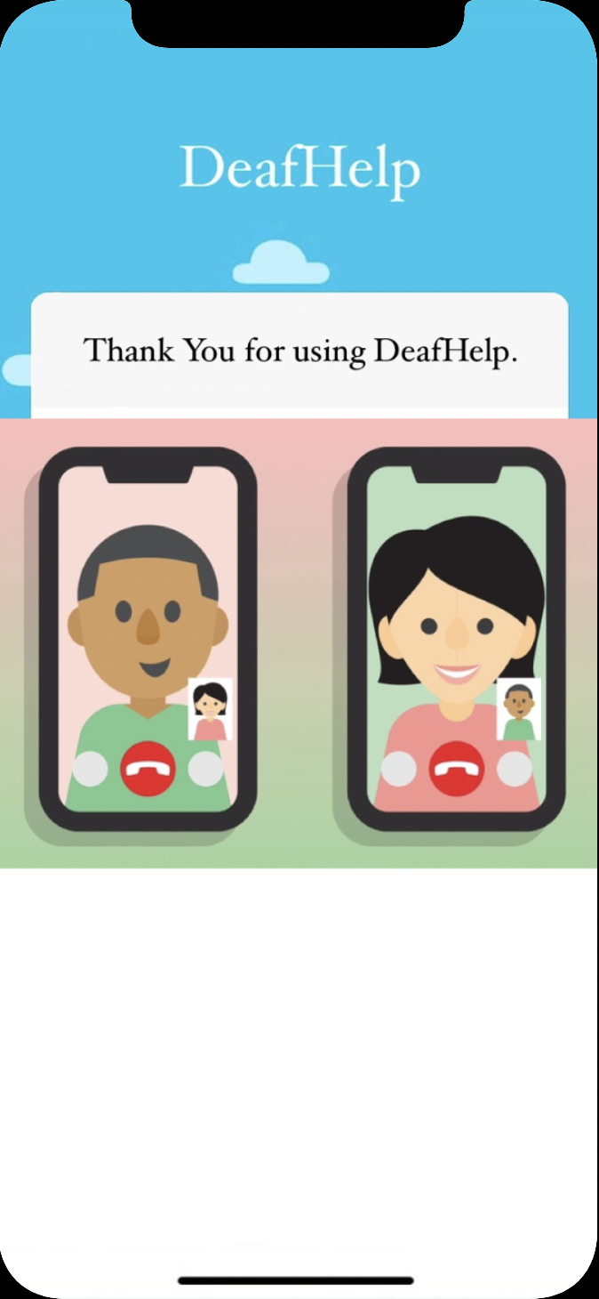In another case, if you feel more comfortable explaining the request to the facility you may do so via video call, the DeafHelp worker will be in the video call with you, talking using sign language. When you tell them your request, they will explain to you what you should do, when information needed is provided from both sides the call ends.

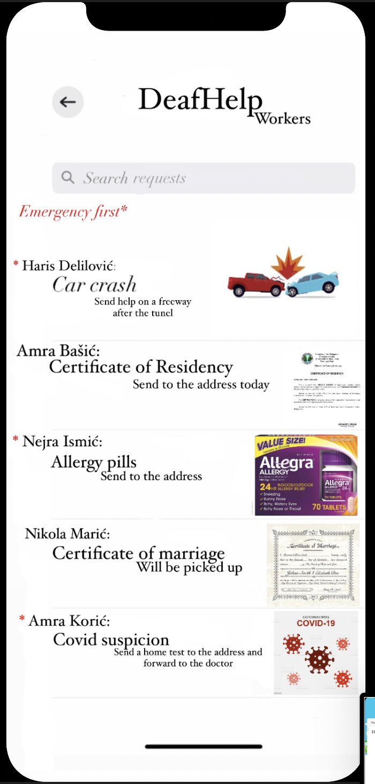Now that we have mentioned the DeafHelp workers, we should explain their role. The workers will log in and register the same way, but instead of the list of facilities there will be a requests page, like in example below:

And by clicking the request the following will appear, where the request will be approved and forwarded to workers who hand out requests, those who help in certain ways needed or kept in the facility and available for pickup.

